# Web Service/Site Setup

1. Install/enable IIS 7 or above
2. Create folder **C:\inetpub\wwwroot\ColumbiaCollege**
3. Create Folder C:\ProgramData\Columbia College

IMPORTANT: set the permissions to this folder to Everyone:Full Control. The logging system needs to write to this path and the code runs under the ASP.Net user context so the folder needs to be very permissive.

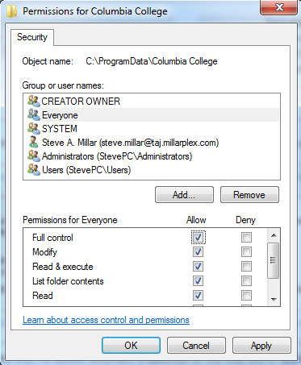

1. In IIS manager
   1. Add Web Site
      1. name is ‘**ColumbiaCollege**’
      2. Application Pool is ASP.NET 4.0
      3. Physical Path: **C:\inetpub\wwwroot\ColumbiaCollege**
      4. Binding: http, All Unassigned, Port 8000, host name blank
2. In VS 2010
   1. Edit **SensorService** project properties under ‘**Package/Publish Web**’ tab
      1. IIS Web site/application name to use on destination server: **ColumbiaCollege/SensorService**
   2. Right click **SensorServices** project and select publish
      1. Name profile ‘SensorService_IIS’
      2. Service URL: http://**YourIPAddress**
      3. Site/application: **ColumbiaCollege/SensorService**
      4. Click publish
3. In VS 2010
   1. Modify a utility method so that it points to a location in your source tree.
      1. Make a note of where the ffmpeg.exe file is located. You are free to move it anywhere you like but it exists in the source tree as “{source root}\ColumbiaCollege\packages\ffmpeg\bin\”
      2. Modify the code in AppDataManager.ToolDirectory to return the DIRECTORY you recorded above. Make sure to include the trailing slash.

public static string ToolDirectory

{

get

{

return @"C:\code\Infinitek\ColumbiaCollege\packages\ffmpeg\bin\";

}

}

1. In IIS Manager
   1. Right click on **ColumbiaCollege** web site and choose ‘Add Application’
   2. Alias is **SensorService**
   3. Path should point to folder that contains the binary files (C:\inetpub\wwwroot\ColumbiaCollege\SensorService\bin)
2. Verify Home Index page is being served properly from a remote browser. You should see this when you browse to http:// {yourIPAddress}:8000/SensorService

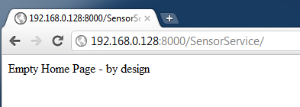

The above step verified the web PAGE serving capability. Now we need to verify that the web SERVICE capabilities are working properly:

Browse to URL:

http://{YourIPAddress}:8000/SensorService/SensorAPI/Ping?val=himom

You just called the PING method which should reflect back your text. You should see the JSON result body in the browser like so:

